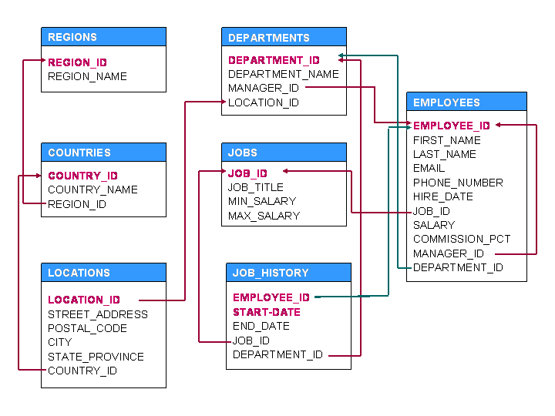

SET A

1. For each city find the maximum salary of IT Programmers(JOB_ID = 'IT_PROG') who have more than 5yrs of experience [experience is sysdate - employees.hire_date]. Print city name, corresponding maximum salary.
2. For each employee, find the total number of employees those were hired before him/her  
   But get less salary than him/ her.Print employee last name, total employees fulfilling the criteria.
3. Find the last names and salaries of those employees whose salary is within ± 5k of the average salary of SALES department.
4. For each job type, find the employee who gets the highest salary. Print job title and first name of the employee. Assume that there is one and only one such employee for every job type.
5. For every city find the month when maximum hiring was done. Print city name, month name,and number of employee hired fulfilling the criteria.